**Assessment of Psychiatric Ward Distribution and Treatment Centers in Israel: Impact on Casualties during the "Haravot Barzel" war**

**Amit Fallach**

**GitHub -** [**https://github.com/amitfallach**](https://github.com/amitfallach)

**Linkedin -** [**https://www.linkedin.com/in/amitfallach/**](https://www.linkedin.com/in/amitfallach/)

**Part 1: Problem Definition**

The ongoing war since October 7th has resulted in approximately 16,500 casualties among soldiers and civilians in Israel. In such times of adversity, every injured individual in Israel has the option to receive psychological support and diagnosis if needed. This study aims to investigate the relationship between the distribution of casualties by region during the Iron Swords War and the availability of psychiatric wards and treatment centers. The goal is to identify areas where casualties are disproportionately high relative to the availability of mental health resources. Preparing in advance can facilitate rehabilitation and the restoration of normalcy for victims and the broader public post-war.

**Part 2: Data Research and Analysis**

Data was gathered from three primary sources: "counseling" [1], "hospitals" [2], and "casualties" [3] datasets obtained from credible sources such as the Ministry of Health and government databases. These datasets include information on counseling centers for families of mentally injured individuals, psychiatric hospitals, psychiatric wards within general hospitals, and total casualties in the "Harvot Barzel" war categorized by districts. The analysis is based on the most recent data available up to the current date.

* **Counseling Centers by District**: Districts with the highest number of mental health centers are Jerusalem, Hadera, and Petah Tikva.

* **Hospitals by District** : Districts such as Jerusalem and Petah Tikva lead in the number of psychiatric departments in hospitals. In addition, it can be seen that in the districts of Kinneret and Rehovot there is no response to treatment departments adapted to children and minors.

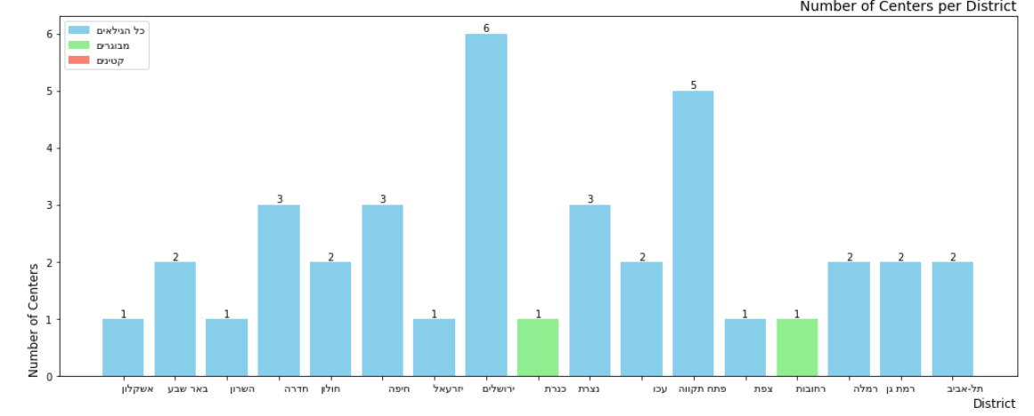

* **Casualties** **by District and cities**: Ashkelon has the highest number of casualties (1240 individuals, accounting for 7.71% of total casualties). Despite resource availability in Jerusalem and Petah Tikva, Ashkelon shows significant demand for psychiatric and social services.

**Part 3: Synthesis and Recommendations**

**Conclusions:**

1. The districts of Jerusalem and Petah Tikva demonstrate strong support for the treatment of the mentally injured and psychiatrists through hospitals, psychiatric wards and social centers. On the other hand, Ashkelon appears to be the district with the highest number of casualties during the war, which indicates a significant demand for psychiatric and social services in relation to the available resources**, so it can be concluded that the departments and centers located in the Ashkelon district and in the same area must be strengthened.**
2. Expansion in North Districts: One could argue that Kinneret and Tiberias are lacking in response to the need for children's and minors' mental and psychiatric treatment facilities (the nearest facility is in Zefat). The disadvantage in these centers will be felt more keenly in the future when the evacuated people of the north return, thus more attention should be paid to a thorough analysis of the demand for centers of this kind or appropriate alternatives in the field. particularly in the Kinneret district in the north.

**Recommendations:**

The data analysis is based on general casualty statistics, presuming that a physical victim receives psychological assessment, therapy, and psychological aid. Further data on the number of hospital beds at each treatment facility, the number of therapists in each location, and the proportion of mental casualties from the conflict relative to the overall casualties can be gathered to further support the findings. This will enable me to evaluate the results' significance and depth with accuracy.

**Bibliography**

[1] Counseling centers for families of mentally injured people, link to the data set <https://data.gov.il/dataset/mtl-families-centers/resource/cef1c51a-452f-484d-8834-6bd77f696ad8>

[2] Psychiatric hospitals and psychiatric wards in general hospitals, link to the data set <https://data.gov.il/dataset/hospitals_psyc/resource/5b4dfe37-ca97-4973-9752-5f1950939832>

[3] The data world of the Ministry of Health - Haravot Barzel, link to the data set <https://datadashboard.health.gov.il/portal/dashboard/health>